Project Design Phase
Solution Architecture

Date | 04 October 2026
Team ID | Team 10
Project Name | Import Data using Transform Maps
Maximum Marks | 4 Marks

Solution Architecture:
Solution architecture is a complex process – with many sub-processes – that bridges the gap between business problems and technology solutions. Its goals are to:
- Find the best tech solution to solve existing business problems.
- Describe the structure, characteristics, behavior, and other aspects of the software to project stakeholders.
- Define features, development phases, and solution requirements.
- Provide specifications according to which the solution is defined, managed, and delivered.

Solution Architecture Diagram:

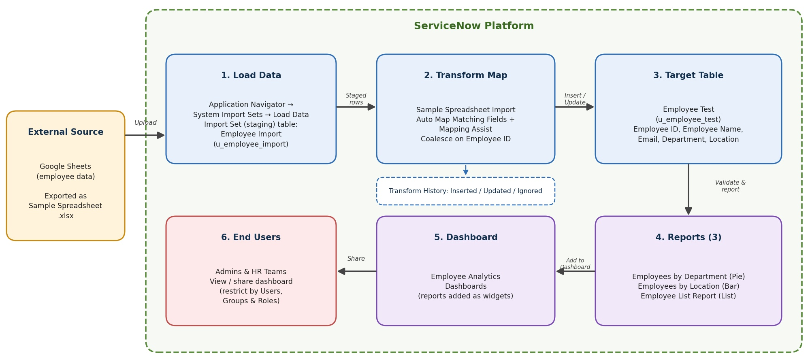
Figure 1: Architecture and data flow of the Import Data using Transform Maps project in ServiceNow
Reference: https://www.servicenow.com/docs/r/yokohama/integrate-applications/system-import-sets/c_CreatingNewTransformMaps.html

